**Immutable Infrastructure**

* Changes in the Infra are not allowed directly.
* Any changes required have to be done by provisioning i.e. create a new image for VMSS (Azure)/ASG (AWS)  
  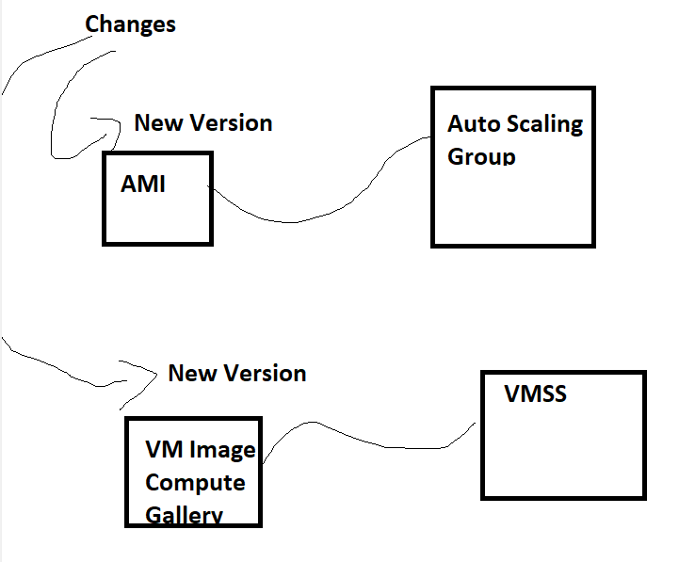
* The creation of Images in cloud is manual so far (what we have learn).
* If we automate the Image creation and if it is triggered by ci/cd pipeline, then we can use this for deployments
* Creating VM Images is specific to Cloud, hashicorp released a tool called as Packer which is used for image creations is various virtual environments
* The ideal workflow could be  
  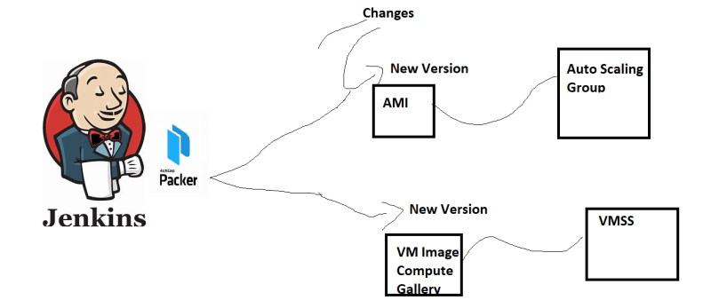

**Packer**

* Packer can be configured in json/HCL (Hashicorp configuration language)
* Terminology:
  + Builder: This is where you want to create image
  + Provisioning: This is where we install the necessary applications which should be part of vm. Here Shell/Powershell/Ansible/Chef etc are supported.
* Installation:
* Download the packer [ <https://developer.hashicorp.com/packer/downloads> ]
* unzip and add the folder to the environment variable PATH  
  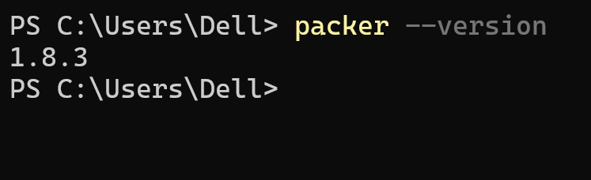

More about packer: <https://developer.hashicorp.com/packer/docs/templates/legacy_json_templates>

**Load Balancer**

* The OSI Model  
  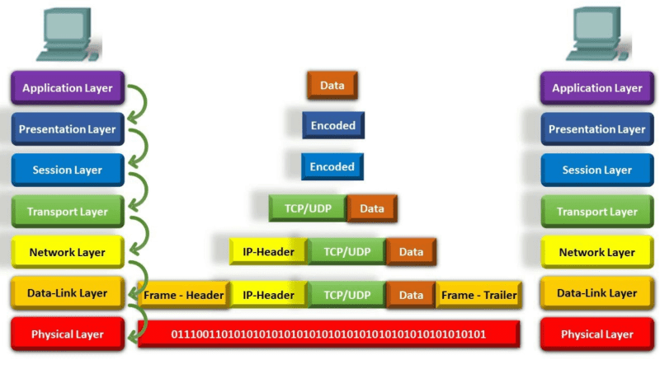
* Layer wise functionality  
  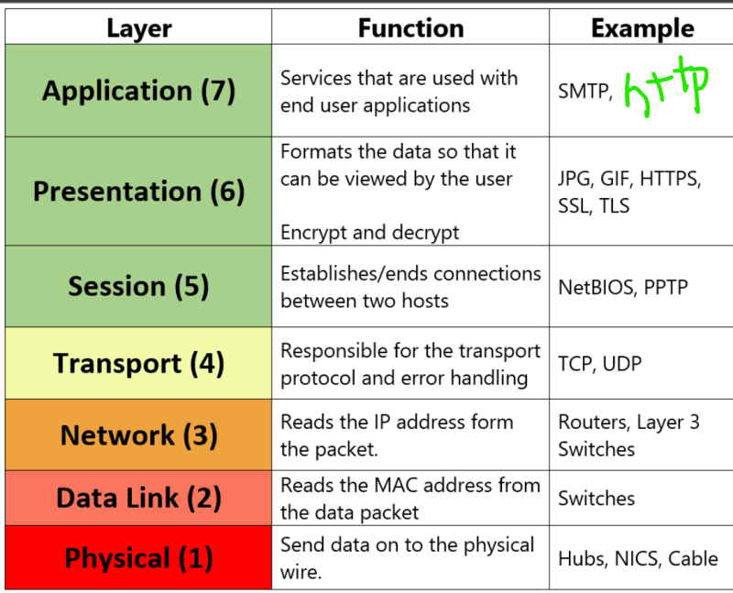
* Transport Layer => Level 4:
  + Ip address
  + port
  + TCP/UDP
* Application Layer => Level 7:
  + http:
    - paths in urls => Routes
    - headers
  + ssl
  + Ip address
  + port
  + TCP/UDP  
    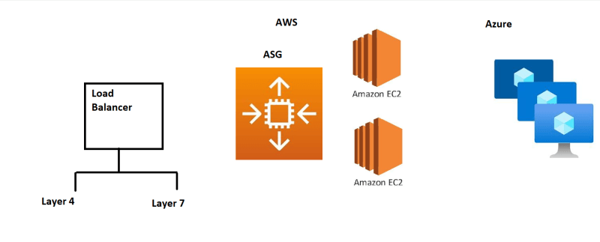
* Layer 4 LB in Azure => Azure Load Balancer
* Layer 4 LB in AWS => Network Load Balancer
* Path Based Routing in Layer 7  
  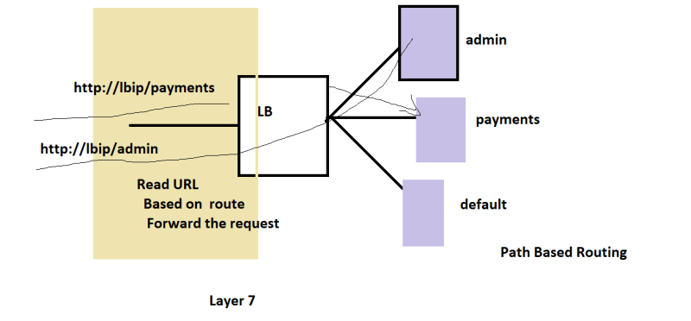

Header based routing in Layer 7  
